PSS Early Maths Activity Ideas for Parents/Carers
Pupil and School Support (PSS) are qualified teachers who support children and young people in educational settings who have learning difficulties.
These leaflets have been created to offer suggestions for support to parents and carers during the COVID-19 crisis.
Children need to have a good understanding of the language of mathematics, quantity, shape and number in real situations, with real objects.
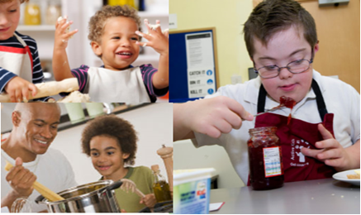
Play shops, making up prices and using coins, modelling comments e.g. that costs more than that.
Play simple board games where your child moves a game piece from one position to the next.
Hide ‘the thimble’ or other object and when they hide the object model language e.g. Is it under the cushion?
Pair socks when washing, pair gloves, shoes etc. and count in twos. When making sandwiches counting in 2s for each sandwich made.
Talk about ‘half, whole, full, empty’ in everyday contexts e.g. Make some sandwiches and cut off the crusts to make a clear square shape from your slices of bread. Help your child to slice up the sandwiches and talk about the shapes. Cut the sandwich in half to make two rectangles. Cut it diagonally into half and you get two triangles!
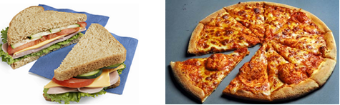
Make cards using shapes, paper and bits and pieces, talk about folding things in half, making patterns and drawing shapes.
Water-play, in the bath or paddling pool in summer, use a collection of objects. Use terms such as full, empty, nearly full, half full.
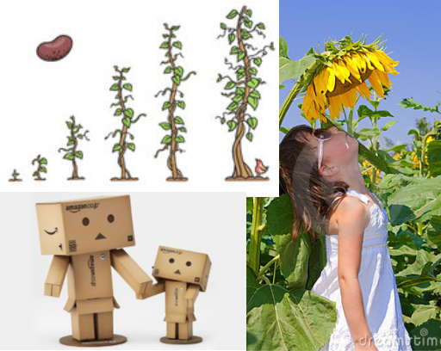
Involve your child in cooking, comparing amounts, weights etc.
Choose some food items out of the cupboard. Try to put the objects in order of weight, by feel alone, but don’t expect your child to read scales.
Explore other ways of measuring using a cup, jug, teaspoon, ice lolly sticks, foot prints or hand lengths.
Encourage your child to guess which glass will hold more juice and then try it out, as this will be fun and increase understanding about volume. Your child will soon discover how containers that are short and fat can hold the same amount as glasses which are much taller and thinner.
As you go about your routines and tasks, use words that help your child to understand time, such as yesterday, tomorrow, next week, last year and so on. Help your child to become aware of time passing, by encouraging your child to notice seasonal changes all around.
Look at family photographs and talk about who is older, younger, or when the child was younger etc.
Make patterns with objects, colouring pencils, paint or Play-Doh. Play with items like shells, bottle tops, beads, Lego and compare them. Try making patterns with them together.
Encourage your child to draw, create and describe their own patterns. Use them for borders or greeting cards or on material.
Build structures with Duplo, Lego or boxes.
Draw shapes, lines, roads etc. on large paper on the floor or on outside using chalk, talk about straight, curved lines and shapes.
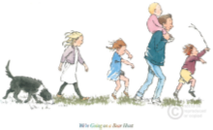

Sing songs and share stories such as Rosie’s Walk (by Pat Hutchins) and We are going on a Bear Hunt (by Michael Rosen), other books to look at shape and pattern are the Elmer series, by David McKee or Grandpa’s Handkerchief by Dorothy Clark, Siobhan Dodds.

