PSS English Activity Ideas for Parents/Carers – Part 2
Pupil and School Support (PSS) are qualified teachers who support children and young people in educational settings who have learning difficulties.
These leaflets have been created to offer suggestions for support to parents and carers during the COVID-19 crisis.
There are three areas of English that we will cover within our ideas, speaking and listening, reading and writing.
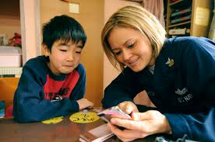
Role-play together, acting out a familiar story or playing vets/doctors/shops .
Play games together to encourage communication, turn-taking and concentration. These could be include snap, catch, board games, pairs, card games, completing a
jig-saw together.
Explore words - talk about new words when your child comes across one.
Enjoy conversations with your child - children learn from conversations with adults as much as their friends.

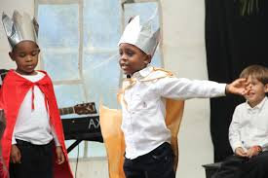
Sharing books with children, spotting targeted words on each page.
Have lots of discussion around words and pictures.
Hide flashcards around the house, creating a trail or treasure hunt.
Active games e.g. use cards or paper with words they are learning to read and ask them to throw the ball to the word and read it or jump on the word and read it. Supporting adult/ older sibling to model this and support.
Play bingo with suitable words on each player’s base boards/cards.

Create a Rhyme – You could use a known nursery rhyme and change some of the words, making it as funny as you can.
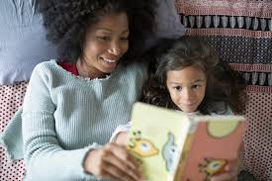
Don’t give up on the bedtime story, even if your child is a good reader. The more stories and books your child hears, the more they will want to read.
Listen to children’s stories online together, e.g. stories.audilbe.com or #operationstorytime,
Use puppets, dolls and construction toy characters to retell or create new stories.
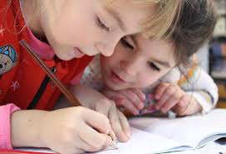
Practice writing any word causing problems as many times as possible (correctly) in one minute. Cover up the word each time, so not just copying.
Write a word with some part of the word missing, ask your child to complete the word.
Noughts and crosses: Mark your space with a word instead of X or O.
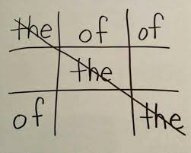
Play hang man using words suitable for your child.
Use a paint brush and water to practice writing letters or words outside on the patio.
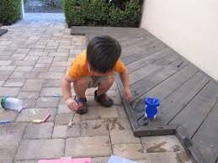
Keep a diary with pictures either labelled with key words or a sentence written to explain what happened that day.
Make cards or write notes to family and friends creating a real purpose for writing.

