PSS Maths Activity Ideas for Parents/Carers – Part 2
Pupil and School Support (PSS) are qualified teachers who support children and young people in educational settings who have learning difficulties.
These leaflets have been created to offer suggestions for support to parents and carers during the COVID-19 crisis.
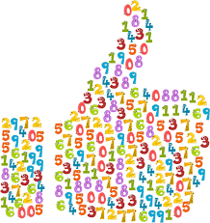 | Play games to read, write and recognise numbers.  Support your child to estimate (guess) how many there are as well as count e.g. how many seeds in the pack.
Play number spotting games at home, look for numbers on packages, clocks, coins, who has the biggest/smallest, most/least, which are odd/even, what is the difference.
Have fun with numbers and make sequences and patterns together, grouping items into 2s, 5s or 10s using items such as coins.
Make cards for family and friends birthdays – put stickers and stamps on, counting and making comments – how many do we need? You have put on three, we need to have 5, so let’s count on as we add more.
Add the total of cutlery at the table. If they had double the number of people how many spoons etc. would they need?
Pair socks when washing, pair gloves, shoes etc. and count in twos.
Count items which come in pairs or groups e.g. rolls, fruit/vegetables, yoghurts etc.
When making sandwiches counting in 2s for each sandwich made.
When using money count in twos and tens when using 2p and 10p coins.
Talk about the numbers you encounter "5 x 8 = 40 that's mummy's age" , "3 x 5 = 15 that's our house number" . . . this makes more memory hooks. Focus on relevant times tables for your child.
Support learning of times tables – complete one at a time, start with the easiest 2x, 10x, 5x. Look for patterns and links e.g. 2 x 5 = 1 x 10. Whilst there are plenty of commercial CDs and applications, children can have fun singing them with adults.
Create a multiplication fortune teller – this is a fun variation of the chatter boxes / fortune tellers school children make out of squares of paper – but rather than predicting your favourite colour, this one helps with learning times tables.
One ladybird has 6 spots, how many spots would two ladybirds have? Ten ladybirds? |  | 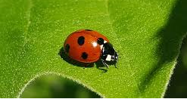
Cooking - get children to help to weigh food, time how long food is in the oven and estimate portion size.
Use catalogues to identify numbers and attempt to add/ subtract numbers, use numbers appropriate to your child. Make up shopping lists.
What is the difference between the minimum and maximum temperature for each day?
Find a seven-day forecast then record the actual temperature for each day and compare. What were the similarities and differences?
Use the information on the weather website to explore differences in weather from your area to others.
Playing simple board games which involve counting on, back and number recognition.  Play games such as Top Trumps. Play card games e.g. Uno |  |  | 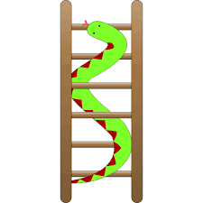
Use playing cards put them in order from largest to smallest by counting the shapes (hearts, spades) or using the numbers on the cards.
Use dice. Roll the dice and say, make or write the numbers identified. Roll the dice and add the numbers together to find the total or take them away or even multiply!
Play games/sport, how many goals can they score altogether?
Write the answers on pieces of paper and place them on the floor. Get a friend/family member to call out the questions and jump onto the correct answer! (ask an adult to check that this is safe – try to avoid slippery floors).
With a partner throw a ball calling out the answers to the times table you are learning. Try starting at different places.
Play hopscotch – initially count on more or then you could put the answers to x tables on the squares. Throw a pebble and call out the respective question for the number.

