

**Communication and Autism Team (CAT)**

**Distractions to break things up**

**while at home.**

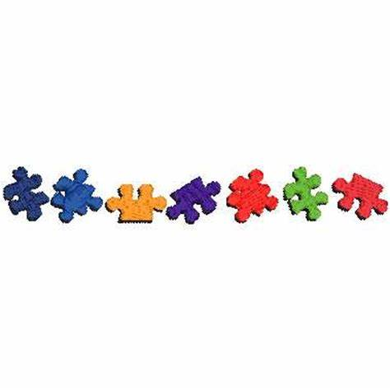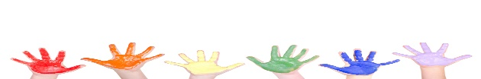

***COMFORTING* - Cuddling soft toy or animal Sleeping Allowing yourself to cry**

**Drinking hot chocolate Wearing your pyjamas Taking a bath or shower**

**Wrapping yourself in a warm blanket Talking to a friend on the phone/computer**

***BEING INSPIRED* - Looking into the sky and watching clouds (from a window or garden) Watching a candle burn**

**Meditate Doing yoga Looking at works of Art Practice mindfulness *Focussing closely on a shell, rock or small object* Watching birds fly (from a window or garden)**

***FUN* - Watching You Tube Listening to music Colouring Using make up**

**Popping balloons Looking online Building towers Playing computer games**

**Completing puzzles/word searches/crosswords Playing games outside in the garden**

***CONSTRUCTIVE* - Doing schoolwork Untangling string or necklaces Cleaning Reading a book**

**Dying hair Stamping on cans Writing a list of what’s working Baking**

**Painting nails Gardening Cooking Tidying Building Lego**

***BEING WITH OTHERS IN YOUR HOME* - Phoning/Videoing friends or family members Hugs Playing cards**

**Helping someone at home – doing jobs Playing a board game Doing a jigsaw together**

**Talking about difficulties with someone you trust Watching a film/TV programme with someone**

**Read a book or magazine together**

***CREATIVE* - Writing things down – diary/ letters/ poems Doodling or scribbling on paper Knitting**

**Playing a musical instrument Writing a song Sewing Drawing Putting on makeup Origami**

**Memorising song lyrics Putting together a playlist of favourite songs Creating a story Painting**

**Creating your own TV Show/Movie Singing Making instruments from things found at home**



***PHYSICAL* - Exercise Punch a punch bag Having a pillow fight Walking up and down the stairs**

**Ripping up paper Popping bubble wrap Playing with a stress ball Plucking your eyebrows Throwing socks against a wall Stamping your feet Running on the spot Shout and scream**

**Clapping your hands Playing hide and seek Dressing up**