

**Communication and Autism Team (CAT)**

**Visual Timetables**

Visual timetables help communicate the structure and sequence of the day by physically showing it. It provides routine and predictability which helps to decrease anxiety and behaviours associated with stress. They explain when things are going to happen and when things are going to change or finish.

A visual timetable is made up of a series of objects, photos/pictures, symbols or written words. Use whichever is appropriate for your child’s level of understanding.

Once each activity has been completed, it is then taken off the timetable and placed in a finish box or folder/envelope. This helps to show that the activity has been completed and what is next.

In the beginning you will need to guide your child through the process by showing the picture/symbol/word on the timetable at the beginning of each activity. Visual timetables can be used to prepare for unexpected changes in routine which are often challenging for children with autism.

Below and on the next page are some examples we have put together, we have used mainly symbols, but you can substitute objects, picture, photos and or words.

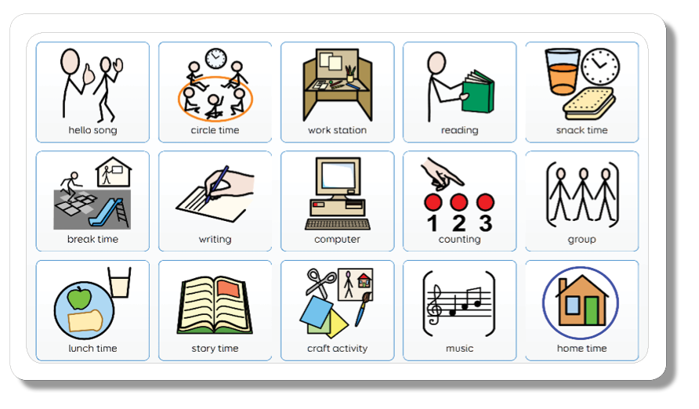





**Communication and Autism Team (CAT) Visual Timetables - Examples**

