Why I need to protect my Nannie and Grandad

We have a new virus called COVID 19 that is making some people very poorly. The Doctors and medical scientists are still finding out lots of information about COVID 19.
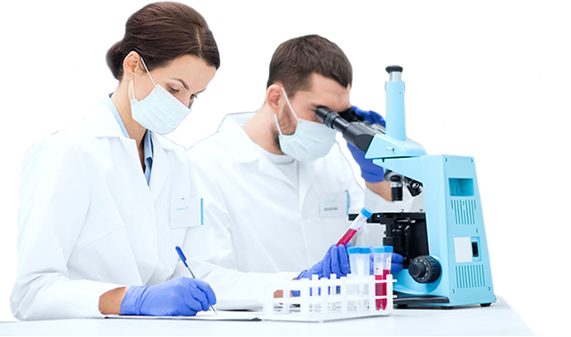
COVID 19 seems to make people who are older like grandparents more poorly than younger adults and children.
In fact most children do not seem to be very affected by it.
The government have asked everyone, for now, not to meet up with grandparents indoors in order to protect them.

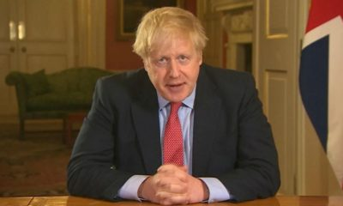

Medical scientists are currently working hard to find the best medicines that will help grandparents get better if they become ill.

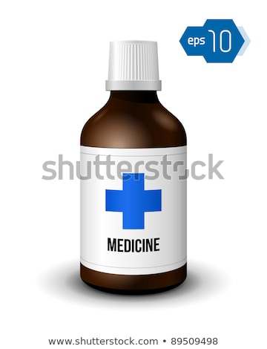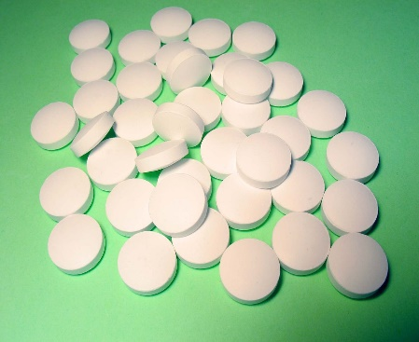
This Photo by Unknown Author is licensed under CC BY-SA

Until then they have told us it is best to meet grandparents outdoors and to keep a distance between us of about 2 meters. This means we can’t hug or kiss them just yet.

The Government will tell us when it is safe to meet our grandparents indoors and when we can get closer to them.

Then we will be able to meet with our grandparents like we did before and give them the biggest hugs and kisses we can.
In the meantime :
I can meet with Nannie and grandad in the garden (and remember to keep at a distance).
I can phone or face time Nannie and Grandad.
I can blow kisses and tell them how much I love them.
I can make them small gifts like pictures and cards.

