How I can help myself to keep safe when I am out of the house.

In March a new virus called COVID 19 was discovered. It spread quickly making some people very poorly. The Government told us all to stay at home to let the spread of infection slow down.
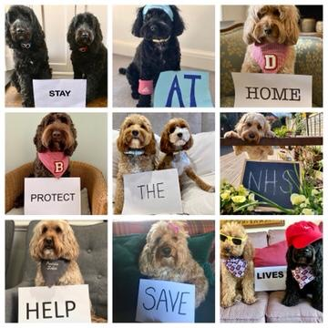
While we were at home the Doctors and medical scientists have been finding out lots of information about COVID 19.
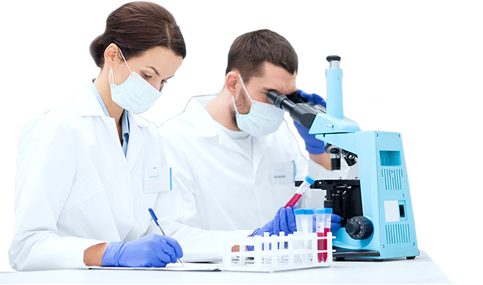
It seems COVID 19 is spread by people that have the virus. Many people who have the virus don’t feel ill. They can spread the virus to others without being aware that, that is what they are doing.

They have also found out that not many children are catching COVID 19 and it is older people who are more likely to become ill.

The scientists and the government have discovered if we keep a social distance away, 2 meters, from people we don’t live with and wash our hands regularly it helps to keep all of us safer.

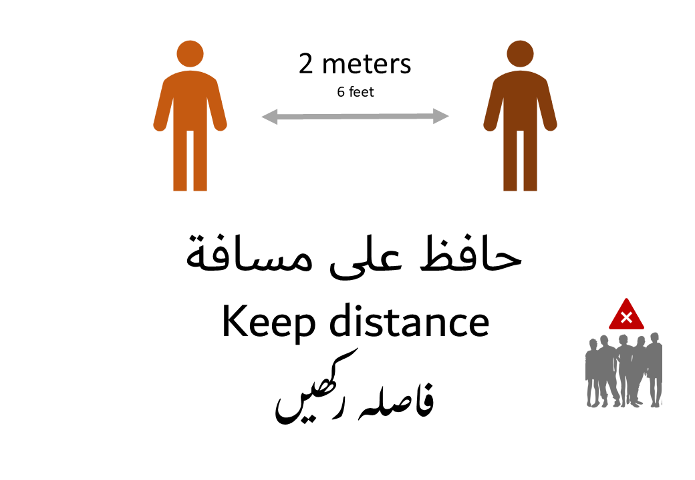
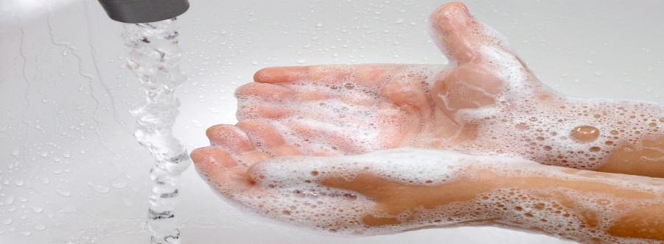
The Government have now said the rate of infection has slowed down.
It is now safer for us to leave our house to shop, exercise or meet a person we don’t live with in an outside space. As long as we keep a distance of 2 meters form others.

To help us keep our distance when we are shopping some shops have made new rules and ask us to queue outside to let a few people in at a time.

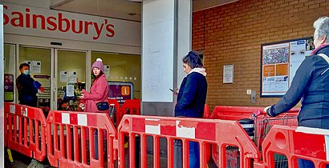

Some shops have put 2 metre markings on the floor to show us where to stand while waiting to go in or when queuing to pay.
Some shops have put markings on the floor to show us which way to go around the shop.
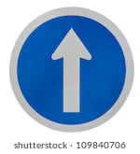
Some shops have also put plastic screens up by the tills. You may see other things that help.

All these things help us to keep our distance from others and help to keep ourselves and others safer.

When I go out to the shops or to exercise my Mummy will help me to keep a distance of 2 metres.

That way I will be able to keep myself and others safer.

This Photo by Unknown Author is licensed under CC BY-SA-NC

