How I can help myself to keep safe when I am out of the house?

A new virus called COVID 19 has made some people very poorly.

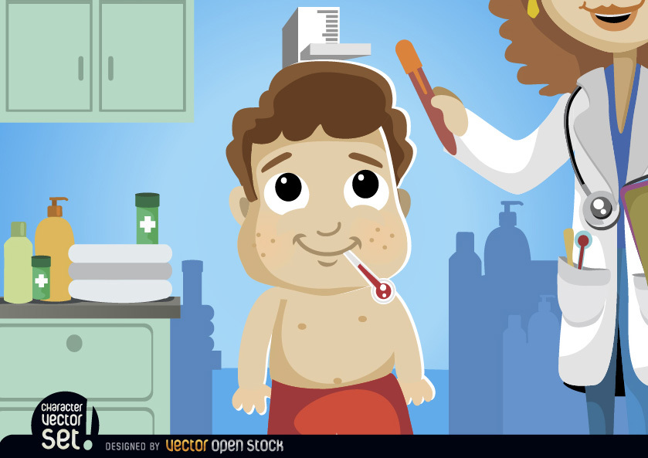

I have been staying at home to keep everyone safe
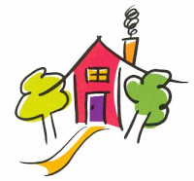

Doctors and scientists have been finding out lots of information about COVID 19.
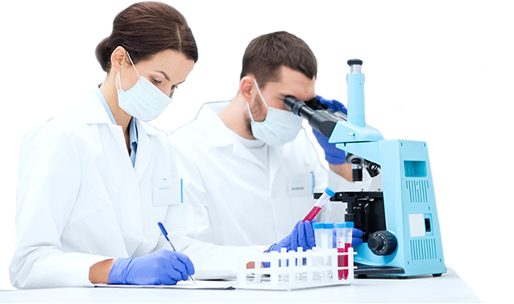

They have found if we keep a distance between ourselves and people we don’t live, use hand sanitiser and wash our hands regularly it helps to keep all of us safer.

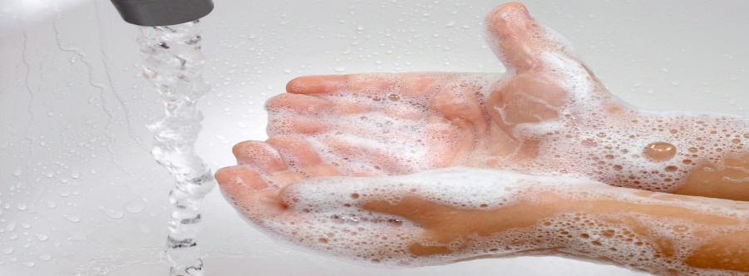

We have been told it is safe for us to leave the house to exercise or meet a person outside that we don’t live

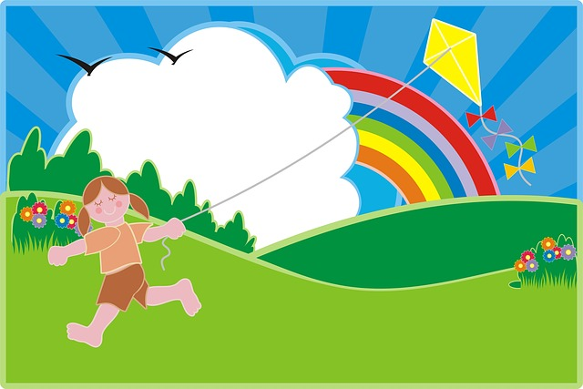

As long as we keep at a distance from people we don’t live with.

We can leave our house to shop

Most shops have tried to help us keep our distance from each other.
Some have asked us to queue outside.
Some have put markings on the floor.
Some have put screens up
These will help us keep our distance from people we don’t live with

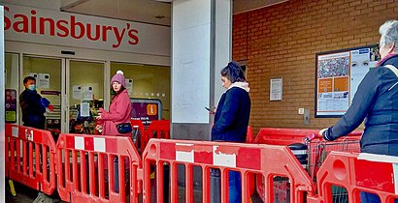

When I go out to exercise.
When I meet some-one I don’t live with
When I go to the shops my Mummy will be with me.

My Mummy will help me to keep a distance of 2 metres from others.

My mummy will tell me when I should use hand sanitiser or wash my hands.

That way I will be able to keep myself and others safer.

