Supporting your child with reading and spelling
The Alphabet Arc
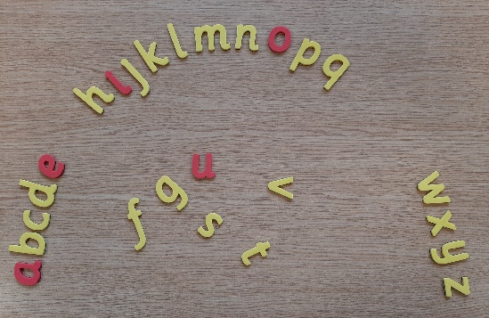
What is an Alphabet Arc?
An Alphabet Arc is a multi-sensory tool that involves setting out 3D wooden or plastic/magnetic letters in an arc. The curved layout and use of colours support visual memory. Multi-sensory learning is important for all learners but can be particularly useful for learners with dyslexia.
Activities carried out with these letters help to develop:
• Knowledge of letter sounds and names;
• Alphabetical order fluency;
• Sequencing skills;
• Blending and segmenting skills for reading and spelling.
abcdefghijklmnopqrstuvwxyz

How to get started
Your child should be sitting in the middle of the arc with MN directly in front of them. Think of your child sitting in the middle of the arc of a rainbow.
Teach the markers
a mn z

Setting out the Alphabet Arc
There are a number of ways of doing this:
- From a to z
- At random from a heap or keep the letters in a bag
- Use ‘mn’ as the starting point and then one to left, and one to the right
- Timed - aiming to beat previous best time
- Set out just the first half or second half to reduce the time.
- Reverse order - Set out in random order then change to alphabetical order.
Your child should name* each letter as they put the letters out.
Alphabet Arc Activities:
Touch and Name [Letter Sound or Letter Name – both should be supported over time]
Ask your child to touch and name each letter in alphabetical order. Use a timer to speed up responses but ensure that the letter is being touched as it is said – this is essential for multisensory input.

Increasing alphabet knowledge
- Touch and name* letters given as quickly as possible.
- Close eyes and point to where a given letter is.
- Trace a letter on your child’s back – they name it and then find it in the arc
- Identify letter before/after a given letter
- Hide a letter, close the gap and ask which letter is missing

Vowels
- Ask your child to find the vowels (a,e,i,o,u) and take them out of the alphabet line.
- Ask your child to touch a consonant
- Say the vowels and consonants out loud to identify the difference between vowel and consonant sounds
- Teach that vowels can have a long and short sound.
- Ask your child to say the short sounds of the vowels ă ě ĭ ŏ ŭ
- Ask your child to say the long sounds of the vowels ā ē ī ō ū

Auditory sequential memory and/or visual sequential memory
- Give your child a sequence of letters to remove from the arc.
- Avoid sequences of letters where the letters sound similar or look similar – to reduce confusion until confident.
- The sequence of letters could either be presented visually on a card or by listening.
- Once finished the sequence (cover it if shown visually)
- Ask your child to copy the sequence and check back for accuracy.
- Discuss strategies with your child e.g. chunking, rehearsing, analogy, mnemonics to find strategies that help them to remember the ‘odd sequence’.

This video clip below will support with the correct articulation of sounds: https://www.youtube.com/watch?v=wBuA589kfMg
This clip with long and short vowel sounds
https://www.youtube.com/watch?v=4TjcT7Gto3U&list=PLPdaL_UVXsU4dZrqAVbCX2saCaxAphjvv&index=26&app=desktop

