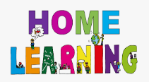
PSS: Supporting My Child with Dyslexia
Learn to Touch Type
If you have access to a computer, you might want to consider using this to teach your child to touch type.
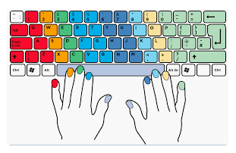

What is touch typing and why is learning to touch-type such an important skill to have?

Any child with dyslexia will be an adult with dyslexia and being able to use a keyboard will be an invaluable life skill.

It reduces the need for handwriting which can often be a challenging area for those with dyslexia.

Touch Typing (or any typing) provides access to the support that technology can bring for writing e.g. autocorrect, spelling and grammar checkers etc.

The more a person improves their typing skills, the more it becomes an automatic skill just like learning to ride a bike!

When typing you become used to the pattern of letters. This muscle memory helps with common letter combinations e.g. "ight", occurring in words such as "fight", "light" and "right"

Once touch typing becomes an automatic skill, it is much easier to concentrate on the creative aspects of writing; this helps children and young people with dyslexia play to their strengths, without having to worry about the process of putting letters together to form words.

Top Tips When Learning to Touch Type

Make it fun!
Use programmes that are games-based to introduce your child to touch typing

Little and often
Touch typing programmes are designed for your child to work on independently. Find pockets of time during the day when they can have a go on their own and keep the sessions short
Access free resources available on the internet
There are a number of programmes that can be accessed for free

Touch-typing Resources
Free resources
- BBC Dance Mat Typing: https://www.bbc.co.uk/bitesize/topics/zf2f9j6/articles/z3c6tfr
- Big Brown Bear:
https://bigbrownbear.co.uk/learntotype/
- Doorway Online:
https://www.doorwayonline.org.uk/typing/
- Kidztype:
https://www.kidztype.com/

Further resources
These incur a cost, although they may be offering significant discounts during COVID-19)
- Nessy Fingers
https://www.nessy.com/uk/product/nessy-fingers/
- Touch-type Read and Spell
https://www.readandspell.com/

