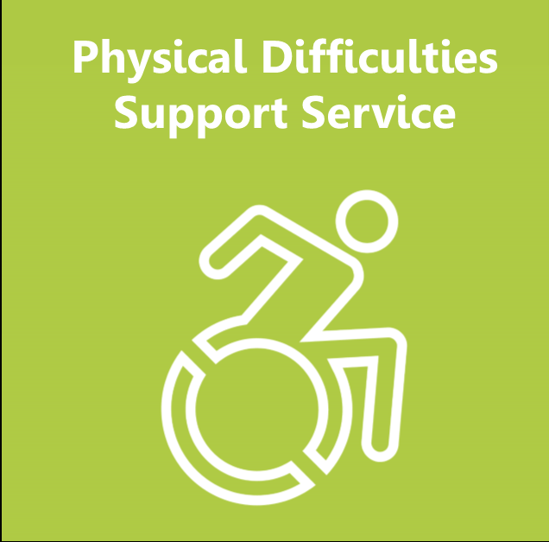
Physical Difficulties Support Service
Referral Form

WE ACCEPT REFERRALS FOR CHILDREN AND YOUNG PEOPLE WITH MODERATE/SIGNIFICANT PHYSICAL DIFFICULTIES AS THEIR PRIMARY AREA OF NEED
* Please read the Guidelines for Referrals (page 4) before completing this form*

Please email completed forms to - PDSSReferral@birmingham.gov.uk

Personal Details of Pupil
Forename: | Surname: |  |  |  |  | Preferred name:
Date of Birth: |  |  | Gender:
Year Group: |  |  | Preferred language:
Wheelchair User: Y/N |  |  | Child in Care: Y/N
EHC Plan: Y/N

Placement Details
School/Setting: |  | Tel No:
Address: |  | SENCO Name:
Postcode: |  | SENCO Email:
SENCO working days |  | Mon |  |  | Tues |  | Wed |  | Thurs |  | Fri
 |  | am |  | pm | am | pm | am | pm | am | pm | am | pm

Pupil’s strengths, likes, interests etc.

Referral Information
Details of condition/diagnosis and health needs:

Details of moderate/significant Gross Motor & Mobility Difficulties:

Details of moderate/significant Fine Motor, Daily Living skills and Hand Function Difficulties:

Please give details of all other educational agencies involved (e.g. E.P., PSS, CAT)
Name |  | Agency |  | Contact Details
Please give details of all medical agencies involved (e.g. Hospital Consultant, Physiotherapist, Occupational Therapist)
Please enter names with contact details below
Name | Agency |  | Contact Details

Parents/Carers details
Forename: | Surname:
Forename: | Surname:
Home Address:

Postcode:

Tel No: | Relationship to Child: | Parental responsibility: Yes
Email:

Parents/Carers permission must appear in writing to enable PDSS to process the referral and arrange a visit
I give consent to the Physical Difficulties Support Service to work with my child. (PDSS is a commissioned agent of Birmingham City Council)
I understand that the above personal data will be stored and managed in line with Birmingham City Council’s compliance to the General Data Protection Regulations.
The Physical Difficulties Support Service (PDSS) will share and request information with your child’s educational setting and other external agencies including health professionals when necessary, for example this may include contacting a child’s physiotherapist or consultant.
We understand that your personal data is important to you, and we have a responsibility to you regarding the information we hold about you, to ensure that the information we collect, and use is done so proportionately, correctly and safely.
Being transparent with you and providing accessible information about how we use your information demonstrates our commitment to the General Data Protection Regulations, referred to as ‘GDPR’. (Regulation (EU 2016/679)
Amending/Withdrawing your consent - You have the right to amend or withdraw your consent at any time. Withdrawing your consent will affect the services and support that PDSS provides to your child. If you would like to withdraw your consent, you must submit your request in writing to PDSS, Oakhill Centre, Oakhill Close, Birmingham B17 8DE.
Parents/Carers
Signature: | Print Name: | Date:
Signature: | Print Name: | Date:

Physical Difficulties Support Service
click on the link below to access PDSS information on the website.
Access to Education | Physical Difficulties Support Service (birmingham.gov.uk)

Criteria for Referral
- Children and young people with moderate/significant physical difficulties as their primary need.
- Children with a medical condition, which affects their physical access to the school day.
- Children and young people from the term before school nursery age, up to year 11 will be accepted.

We do not accept referrals for –
- Children with Global developmental delay where their physical difficulty is in line with their development in other areas.
- Children with a diagnosis of ASD unless they have a significant physical difficulty.

Information and Guidelines
All referrals must be completed by Educational Providers using the appropriate standard referral form.
- We can only accept a referral once forms are signed by parents/carers/and or designated person for a Children in Care who has parental responsibility.
- It is essential that the SENCO’s email address is on the form.
- Please scan and email completed forms to your relevant PDSS Base.
- All referrals are discussed by the PDSS Team. If the referral meets PDSS criteria we will contact, you to arrange an initial visit.
- If the referral does not meet our criteria, we will notify you of this.
- Following the initial contact appropriate support will be agreed with the setting.

