

**Pupil and School Support**

**Speech and Language Therapy**

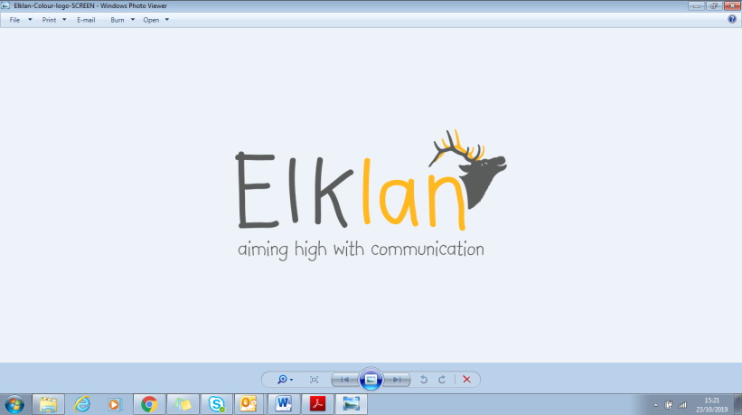

**Speech and Language Support for 5-11s**

PSS and Locality SaLT are delighted to offer Elklan ‘Speech and Language Support for 5-11s’ course to schools wishing to train a member of staff to become a lead practitioner for supporting children with SLCN across the school.

**What are the benefits to the school?**

* Elklan trained participants will have the skills and knowledge to support the wider school team.
* Improved identification of children with speech, language and communication needs.
* Participants will be able to offer range of tools and methods to enhance children’s learning in the classroom and during intervention.

**Who is the course for?**

Teaching assistants or teachers working in primary settings (supporting children aged 5-11).

**What does the course involve?**

The course may be structured as either:

* 3 full days face to face training, spaced a month apart to allow time for weekly learning tasks to be completed.
* Weekly e-learning and 1 hour seminars over 10 weeks, with weekly learning tasks to be completed.

Participants will be asked to complete learning tasks between training sessions in order to qualify for Level 3 accreditation.

**Cost: £450 per person**

Cost includes a copy of the ‘Elklan - Language Builder for 5-11s’ book or e-book and accreditation fee.

Lunch is not provided for the three day course.

The course can also be offered to groups of schools in a locality wishing to purchase at a cost of £3,500 + £67.50 per person (accreditation fee). Maximum of 15 people.

If you would like to express an interest in this course please contact:

[Lesley.M.Brine@birmingham.gov.uk](mailto:Lesley.M.Brine@birmingham.gov.uk)

**What does the course teach?**

The Elklan ‘Speech and Language Support for 5-11s’ course aims to develop your skills in supporting all children with their communication development, but especially those with speech, language and communication needs. It will equip you with innovative tools and methods to enhance your pupils learning in the classroom and promotes quality first teaching. You will be taught using engaging and relevant teaching methods which includes practical activities, videos and group discussions.

1. **WHAT IS COMMUNICATION?**

* Identify the processes involved in communication.
* Demonstrate the wide range of communication difficulties and the impact these have on the child.

1. **IMPROVING LISTENING, ATTENTION AND INDEPENDENT LEARNING SKILLS.**

* Identify non-verbal communication behaviours.
* Explore strategies to support children with poor listening and attention.

1. **LISTENING, MEMORY AND UNDERSTANDING SPOKEN LANGUAGE.**

* Explore a simple model of memory.
* Learn about strategies to enable differentiation whilst supporting memory and independent learning.

1. **MODIFYING ADULTS’ SPEECH TO HELP A CHILD UNDERSTAND LANGUAGE.**

* Practise modifying the adult’s language through an understanding of Information Carrying Words.

1. **UNDERSTANDING BEYOND SIMPLE SENTENCES.**

* Discuss supporting verbal reasoning skills, including why & how questions, inferences, sequencing, predicting.
* Practise modifying the adult’s language accordingly.

1. **PROMOTING VOCABULARY DEVELOPMENT.**

* Identify vocabulary to target.
* Develop a range of strategies to support the learning and retention of new words.

1. **ENCOURAGING EXPRESSIVE LANGUAGE AND NARRATIVE DEVELOPMENT.**

* Identify the processes involved in expressive language.
* Consider issues pertinent to children learning additional languages.
* Discuss the development of expressive language and story-telling and how to support children acquire these effectively.

1. **PROMOTING EFFECTIVE COMMUNICATION AND SOCIAL SKILLS.**

* Reflect on the effects that interaction-patterns between adults and children have on communication.
* Share ideas to encourage children to ‘Speak Out‘ and seek appropriate help.
* Identify skills required for successful social communication and learn strategies to develop these.

1. **SUPPORTING CHILDREN WITH UNCLEAR SPEECH AND EXPLORING THE LINK BETWEEN SPEECH, READING AND WRITING**

* Explore the development of speech sounds and clear speech.
* Discuss strategies to support children with unclear speech.
* Consider the link between speech, reading and writing.
* Review phonological awareness.

1. **MANAGEMENT OF STAMMERING AND OTHER ISSUES RAISED DURING THE COURSE.**

* Share ideas to support children who stammer.
* Present evidence of applying knowledge gained across the course during everyday classroom activities.