**Genie Radio aid**

[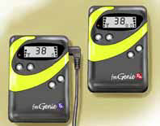](https://www.google.co.uk/url?sa=i&url=https%3A%2F%2Fwww.connevans.info%2Fimage%2Fconnevans%2Ffmg14_v3.pdf&psig=AOvVaw010dQocRJ3cpr64rrF3y9L&ust=1593625192380000&source=images&cd=vfe&ved=0CAIQjRxqFwoTCOCpnc6KquoCFQAAAAAdAAAAABAE)

This is the transmitter (Tx) which the teacher wears

This is the receiver (Rx) which attaches to the hearing aids with the Y lead

[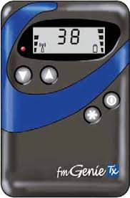](https://www.google.co.uk/imgres?imgurl=x-raw-image%3A%2F%2F%2F88e8ff111f15b4b12afafadd4c550ddd11777ecc70a3b9e53ce57fbba5fe160c&imgrefurl=https%3A%2F%2Fwww.connevans.info%2Fimage%2Fconnevans%2Ffmg144.pdf&tbnid=sbQVHxH_6Ihc3M&vet=12ahUKEwjTtZ_NiqrqAhVGiRoKHVKdB-QQMygKegUIARCoAQ..i&docid=9-9NJ349NXLwhM&w=213&h=322&q=genie%20radio%20aid&safe=strict&ved=2ahUKEwjTtZ_NiqrqAhVGiRoKHVKdB-QQMygKegUIARCoAQ)

Battery indicator

ndicator

Frequency -must be the same as receiver

r

Integral microphone

**The Transmitter**

On/off switch

Mute button



The aerial must be **securely** pushed into the Ex Mic socket of the transmitter

**To connect the receiver to the hearing aids:** …….. may need help attaching the Y lead from the receiver to the hearing aids.

Each hearing aid has a ‘shoe’ attached to the end. This has 3 holes in the bottom. Look carefully and you will see that one of the holes is bigger. Look at the 3 pins on the Y lead and push them into the shoe, with the fattest pin in the biggest hole. You will need to push gently as it is a tight fitting.

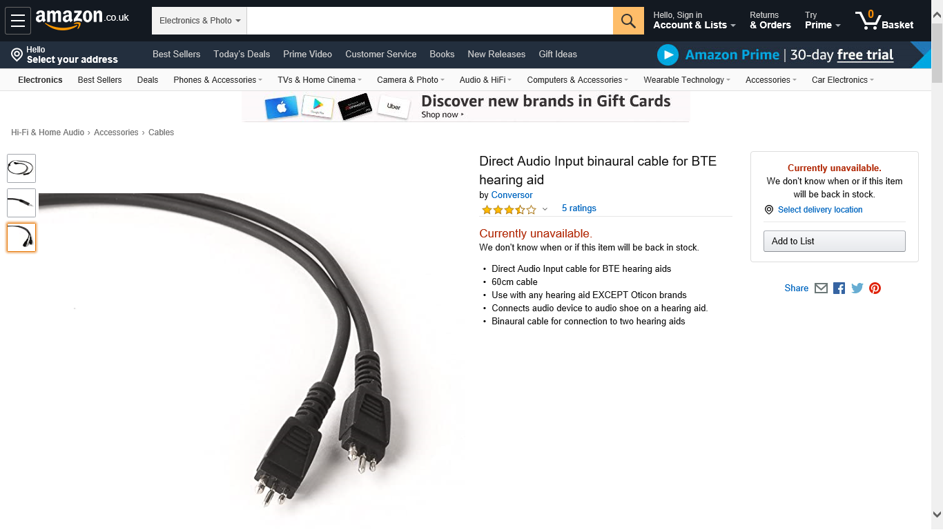 [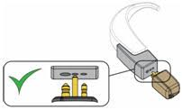](https://www.google.co.uk/url?sa=i&url=https%3A%2F%2Fwww.independentliving.co.uk%2Fproduct-focus%2Fradio-aids-and-streamers%2F&psig=AOvVaw0JAnUhHw9ob16nNlKjQDFI&ust=1593771979517000&source=images&cd=vfe&ved=0CAIQjRxqFwoTCKjb7betruoCFQAAAAAdAAAAABAH) [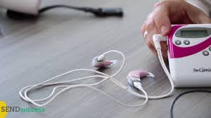](https://www.google.co.uk/imgres?imgurl=https%3A%2F%2Fi.ytimg.com%2Fvi%2FYkSfeG7V0DA%2Fmaxresdefault.jpg&imgrefurl=http%3A%2F%2Fcyberspaceandtime.com%2FLAHE6dBb9Ys.video%2Brelated&tbnid=4a6ajejm7j98-M&vet=12ahUKEwjrjeu1jqrqAhXO_4UKHVj6A0oQMygEegUIARCaAQ..i&docid=rtbJuv-vt6kuaM&w=1280&h=720&itg=1&q=child%20wearing%20genie%20radio%20aid&safe=strict&ved=2ahUKEwjrjeu1jqrqAhXO_4UKHVj6A0oQMygEegUIARCaAQ)

**Please watch this excellent video which shows you how to operate and use the Genie radio aid:**

<https://www.youtube.com/watch?v=YkSfeG7V0DA>

**Using a Radio Hearing Aid – Good practice guidelines**

* Wear the transmitter with the microphone a hand span distance from your mouth

 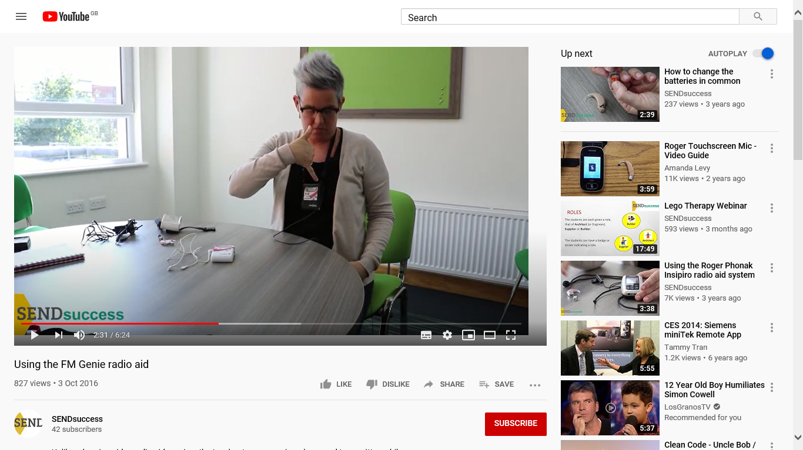

* Remember to mute the transmitter or switch off when you are not speaking to the child or when you leave the room
* Don’t wear loose jewellery etc. that hits against the microphone.
* If using a TV, Video, computer or Soundfield system etc. connect it to the transmitter (you can request a lead from the Sensory Support Service)
* Charge the batteries regularly – remember to turn off before charging.
* Check the equipment every day.

**Daily checks**

Check:

1. both the transmitter and the receiver are turned on! Check again after breaks or lunch.
2. the transmitter and receiver are both on the same frequency and that they are both turned on. Little fingers sometimes toggle with the channel change buttons!!

[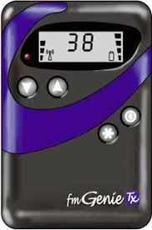](https://www.google.co.uk/url?sa=i&url=https%3A%2F%2Fwww.connevans.info%2Fimage%2Fconnevans%2Ffmg14_v3.pdf&psig=AOvVaw1sTOTTlwYPKKMbOAm6IrYz&ust=1594136234423000&source=images&cd=vfe&ved=0CAIQjRxqFwoTCKDbl7L6uOoCFQAAAAAdAAAAABAP)

1. the battery indicator – does it have enough charge?
2. the batteries are fitted correctly and examine for splits, cracks or damaged
3. the mute button on the transmitter is turned off
4. the aerial is fully inserted into the socket of the transmitter (and inserted in the correct socket!)
5. the direct input leads on the receiver are fully inserted.
6. the three pinned leads are fully inserted into the shoe of both hearing aids.

**Any problems –**

* Are the shoes fitting properly into the hearing aid?
* Are the receiver and the transmitter on the same frequency?
* Are the batteries charged? Try replacing the rechargeable batteries with AA battery – if this works the rechargeable batteries need replacing. Please contact the audiology technicians for new batteries. **DO NOT ATTEMPT TO RECHARGE WHILST THE NON-RECHARGEABLE BATTERIES ARE INSERTED!!**
* Is the aerial fully inserted into the socket?

If the problem persists, please contact the audiology technicians:

Tel: **0121 464 5603** email:[**Sharon.B.Flaherty@birmingham.gov.uk**](mailto:Sharon.B.Flaherty@birmingham.gov.uk)