Good practice guidelines (Roger Select)
The radio aid consists of 2 tiny Roger receivers which attach to the end of each hearing aid and a Roger Select transmitter which the teacher / speaker wears.

On / off button
Hearing aid shoe
Roger X Receiver
Select Transmitter, worn by speaker

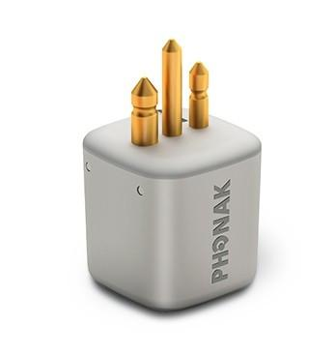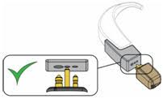
When connecting to the hearing aid ensure that the fatter prong goes into the larger hole

Please watch this excellent video which shows how to connect and use the Select:
https://www.youtube.com/watch?v=P4xgvGv9z64
0.15 Charging
1.32 Turning on/off
1.43 Battery status
2.10 Connecting to receivers
2.53 How to use in conference/ group mode
4.30 How to use in teaching mode(with lanyard)
4.55 Muting and unmuting
5.18 Pairing with Bluetooth devices
5.37 Making a phone call

Connecting the Roger Select

Attach the receiver to the hearing aid (see above) and ensure the hearing aid is turned on.

Turn the Select on – hold the on/off button for a few seconds until green lights come on

Hold the Select close to the hearing aid and press the Connect button . It should connect within a few seconds. It will turn green for two seconds to show it has connected. If the light is red it has not connected – move closer to the receivers and try again.
The Select will connect to other students’ hearing aids if they are in the same group – just follow the procedure above for each receiver.

Using the Roger Select:

The lapel microphone should be clipped at about 20 cm directly below the teacher’s lips. In this position the Select automatically switches on the microphone at the top and this will show as a green light

Recommended distance for microphone

- To check the radio aid is working: From a distance of at least 3 metres away, speak whilst wearing the Select, covering your lower face. Ask the student to do things like “point to the window”, “put up your hand” or repeat a few words etc…
If the system works, they should be able to respond.

- During brief teaching breaks (e.g. 15-min quiet study or speaking to individual students):

- MUTE the microphone by pressing the Microphone Mute button once.
The lights will turn red.
- IMPORTANT: Remember to UNMUTE the microphone when teaching resumes!!
Do this by pressing the same button again once – the lights will turn green

- Avoid loose jewellery, lanyards etc knocking or rubbing against the microphone – this sounds awful through the receivers!
- If using a TV, Video, computer etc. connect it to the transmitter (request a connection lead).
- Charge the batteries regularly – preferably at the end of every day.
Using Select for group work / personal use
When placed on a table or in the palm of your hand the Select microphones automatically default to ‘surround’ mode. This means it will pick up conversations from all around the table:
Tapping here will select this microphone
To listen to speaker sat here
However, you can also choose which direction you want to listen – for example, just one person from around the table. To do this, tap the speaker nearest to that person (see above). You can tap more than one microphone to listen in several directions:
Any Problems-
- Firstly, check the hearing aid battery – the receiver takes its power from that and it is important that it has plenty of charge.
- Check the shoes on the hearing aid are fitted securely
- Check that the receiver is fully inserted into the shoe
- Check that the transmitter isn’t muted and is charged (the light around the on/off switch should be green, not red)
- Hold the receiver close to the transmitter and press Connect again
Problem not sorted? Contact the audiology technicians:
Tel: 0121 464 5603 email: Sharon.B.Flaherty@birmingham.gov.uk

