Using a Radio Hearing Aid – Good practice guidelines (Roger Touch/Roger MyLink)
…… has an Oticon streamer on a neckloop, a Roger X receiver and a Touch transmitter
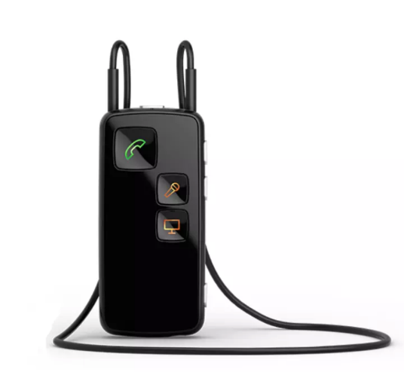
This is the Touch transmitter, worn by the teacher.
On/off switch (hold for a few secs)
Battery indicator
Microphones
Connect to receiver
Mute button
Charging socket
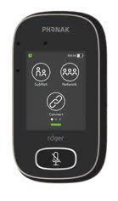

Oticon Streamer
Roger X Receiver

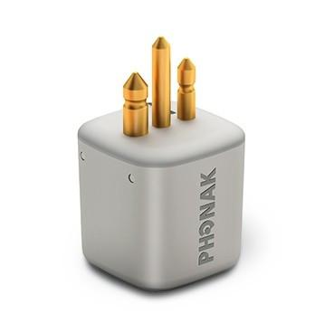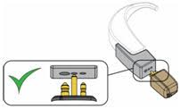
When connecting to the streamer ensure that the fatter prong goes into the larger hole

Please watch these excellent videos which show how to operate and use the Touch:
https://www.youtube.com/watch?v=dfe9TVjl180
https://www.youtube.com/watch?v=LAHE6dBb9Ys – this video shows you how to adjust the lanyard and use the Touch in different settings (worn by teacher / small group or conference mode /‘pointing’ mode)

To connect to the hearing aid:
Turn the Roger Touch on by holding the on/off switch for a couple of seconds.
Hold the Touch close the student’s hearing aids – about 6 cm away. Press the Connect button. The screen should then say ‘A Roger X is connected’
Wearing and using the Touch:
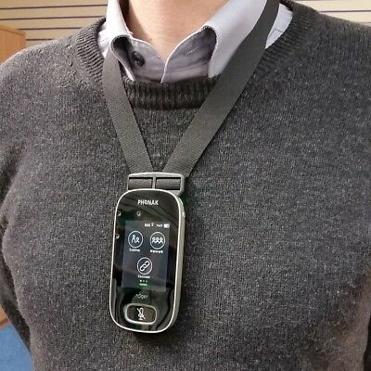
- This is how to wear the Touch transmitter when teaching
- Do not have the lanyard too long or it will not transmit your voice effectively.
- Do not wear jewellery, key lanyards etc which rub against the transmitter. This creates a horrible noise for the listener!
- The screen will go into standby after a few minutes and turn black. It is still working but to turn the lights back on press the power button, NOT the mute button.
- Use the Mute button when you no longer want Qasim to hear your voice e.g. when talking to another group or individual BUT remember to turn it back on again when you need him to hear!!
- Watch the video above to find out how to use the transmitter in pointing mode. This is usually only recommended for older students – if you think this would be appropriate please contact your Teacher of the Deaf for the passcode
- Please pass the transmitter to Qasim when he is working in a small group so that it can be placed on the table in ‘conference mode’.

This short video shows the Touch being used in a classroom: https://www.youtube.com/watch?v=PPW6muXmNmw

Remember to charge the receiver and transmitter every evening! Don’t worry – you can’t overcharge it.

Any Problems?

- First check that the Roger Touch is charged.
- Check the hearing aid battery – the receiver takes its power from that and it is important that it has plenty of charge.
- Check the shoes on the hearing aid are fitted securely
- Check that the Touch has not been muted. It shows red when muted – press the Mute button again and it will turn green.
- Turn the Touch off and back on again and reconnect
If the problem isn’t resolved contact the audiology technicians:
Tel: 0121 464 5603 email: Sharon.B.Flaherty@birmingham.gov.uk

