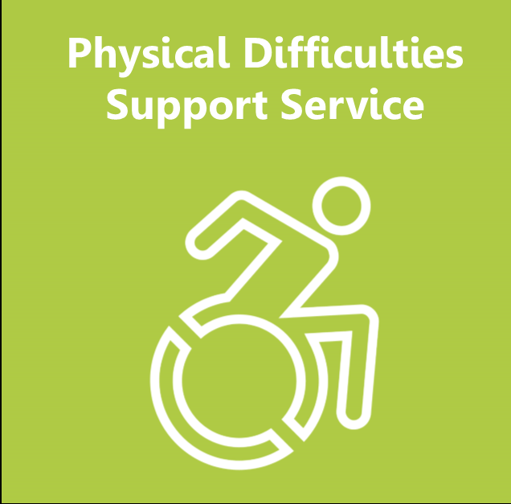
Physical Difficulties Support Service
Referral Form

WE ACCEPT REFERRALS FOR CHILDREN AND YOUNG PEOPLE WITH MODERATE/SIGNIFICANT PHYSICAL DIFFICULTIES OR A MEDICAL DIAGNOSIS AS THEIR PRIMARY AREA OF NEED

* Please read the criteria and guidelines for referrals at the bottom of this form before completing the referral*

This form MUST be completed by the SENCO/professional working with the child.
All sections of the referral MUST be completed in order for the referral to be triaged.

Please email completed forms to - PDSSReferral@birmingham.gov.uk

Personal Details of Pupil
Forename: | Surname: |  |  |  |  | Preferred name:
Date of Birth: |  |  | Gender:
Year Group: |  |  | Preferred language:
EHCP Y N  SSPP Y N  EYS PLAN Y N |  |  | Child Protection Plan Y N  Child in Need Plan Y N  Looked after child Y N
Wheelchair User: Y/N

Placement Details
School/Setting: |  | Tel No:
Address: |  | SENCO Name:
Postcode: |  | SENCO Email:
SENCO working days |  | Mon |  |  | Tues |  | Wed |  | Thurs |  | Fri
 |  | am |  | pm | am | pm | am | pm | am | pm | am | pm

Pupil’s strengths, likes, interests etc.

Referral Information
Details of condition/diagnosis and health needs:

Details of moderate/significant Gross Motor & Mobility Difficulties:

Details of moderate/significant Fine Motor, Daily Living skills, Personal Care and Hand Function Difficulties:

What provision/interventions are already in place to support the pupil?

Please give details of all other educational agencies involved (e.g., E.P., PSS, CAT)
Name |  | Agency |  | Contact Details
Please give details of all medical agencies involved (e.g., Hospital Consultant, Physiotherapist, Occupational Therapist)
Please enter names with contact details below IF KNOWN
Name | Agency |  | Contact Details

Parents/Carers details
Forename: | Surname:
Forename: | Surname:
Home Address:

Postcode:

Tel No: | Relationship to Child: | Parental responsibility: Yes
Email:

Communication with the child and family
Child’s first language |  | Language used within the home
Is an interpreter required for parents? | Yes ☐ No ☐ | If so, which language?

Consent – to be completed and signed by Parents/Carers.
Please tick all the relevant boxes.

I agree to this Request for Support for the Birmingham City Council (BCC) Education Service as identified on this consent form Physical Difficulties Support Service. (PDSS)

I give permission for the Service supporting my child to have relevant personal, medical, and educational information relating to my child.

I agree to Birmingham City Council (BCC) processing my child/family information and I understand that both paper and electronic records may be kept as a result of this Request for Service and that any records will be kept securely and destroyed safely in accordance with BCC Document Retention and Deletion Schedule.

I understand that information (for example - Reports, Learning Targets, Developmental Progress) will be shared with other professionals who are already involved with my child/family, or any other agencies that might become involved with my child or family in the course of any support offered to my child. This will be done in accordance with Birmingham City Council’s Information Sharing Protocols. This will only be information that is relevant and necessary, shared with people who need that information, and, when there is a specific need for that information to be shared at that time.

I understand you will seek consent from me if you want another service, not already involved, to see or work with my child.

I understand that as part of the General Data Protection Regulations, I have a right to request a copy of the information BCC holds about me/my child. For more information, I can contact BCC’s Data Protection Officer at the Corporate Information Management Team, PO Box 16366 Birmingham or email – infogovernance@birmingham.gov.uk

I understand that I can access the BCC Privacy Notice at
www.birmingham.gov.uk/info/20154/foi_and_data_protection/384/privacy_statement/1

Name of parent – please print.

Signature

Name of child

Date of Birth

Date

Physical Difficulties Support Service
click on the link below to access PDSS information on the local offer.

Physical Difficulties Support Service | Local Offer Birmingham
Criteria for Referral
- Children and young people with moderate/significant physical difficulties as their primary need.
- Children with a medical condition, which affects their physical access to the school day.
- Children and young people from 2 years old (N-2) in a nursery setting up to Year 11 will be accepted.

We do not accept referrals for –
- Children with Global developmental delay where their physical difficulty is in line with their development in other areas.
- Children with a diagnosis of ASD unless they have a significant physical difficulty.

Information and Guidelines
All referrals must be completed by Educational or Healthcare Providers using the PDSS referral form.
- We can only accept referrals that are signed by parents/carers and or the designated person for a Looked after Child. (See consent form)
- It is essential that the SENCO’s email address is on the form.
- Please email the completed referral and consent forms to PDSSReferral@birmingham.gov.uk
- All referrals are triaged by the PDSS Team.
- If the referral does not meet our criteria, we will notify you of this and signpost you to other external agencies and appropriate training available.
- If the referral does meet PDSS criteria we will contact, you to arrange an initial visit.
- Following the initial visit, PDSS will provide advice and inform the setting/school of what future provision is required.
- You will be notified if the pupil meets the eligibility criteria for ongoing active PDSS support.

