PSS are pleased to offer a coaching model of specialist teaching, the aim of which is to train a member of school staff to deliver a recognised programme to pupils with dyslexia. This consists of a 6 week or 12 week programme of support from a PSS teacher with the British Dyslexia AMBDA accreditation. The PSS teacher will work alongside a member of school staff to deliver a specialist teaching approach to individuals or a small group of two pupils. By the end of the coaching period, the school staff member will be equipped to continue delivery to these and other pupils with dyslexia.

**Who is it for?**

Pupils with dyslexia for whom progress is limited through traditional teaching methods.

**Benefits**

* Increased capacity for school to support pupils with dyslexia to make progress.
* An excellent CPD opportunity for a member of school staff (Teacher or TA).

**What is included?**

* Consultation sessions with school staff to set up, evaluate and develop teaching.
* Weekly delivery of one modelled lesson, then support with planning the second lesson delivered by school staff.
* Course materials, including published teaching book.

**What does school need?**

* Commitment from SLT to ensure that agreed time and resources are dedicated to smooth delivery to ensure pupil progress.

**Cost**

6 week programme : £1,320 12 week programme : £2,310

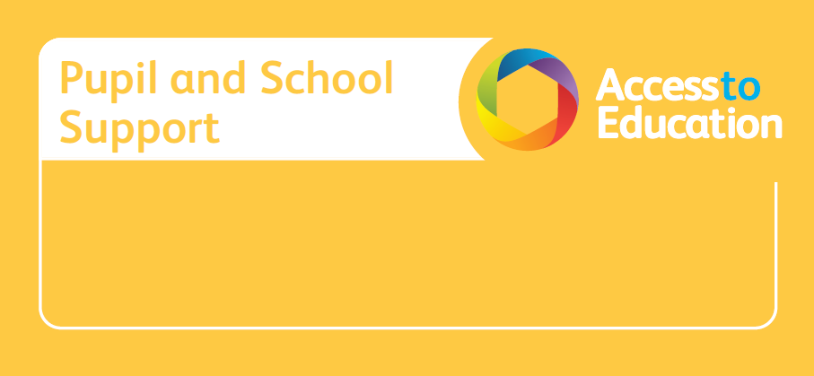

**Specialist Teaching Model**

**for pupils with dyslexia**

Please email PSS for further details or to arrange a package of support

[**pssinfo@birmingham.gov.uk**](mailto:pssinfo@birmingham.gov.uk)