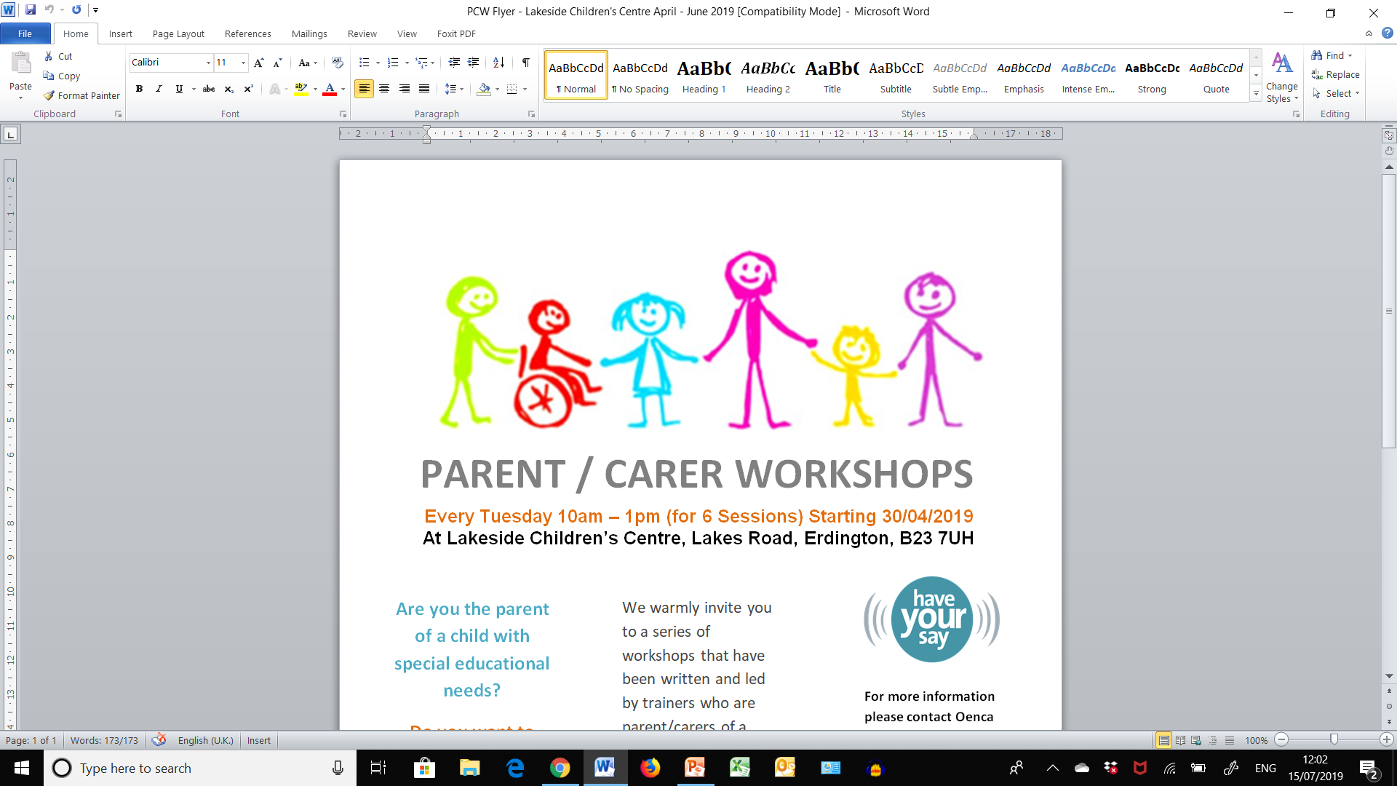

Be Empowered Workshop – Early Support Programme for SEND Parent Carers
We warmly invite you to join in a series of daytime online workshops that have been written and led by trainers who are parent/carers of a child with additional needs themselves.
These workshops are for parent/carers of children and young people of any age, with any additional need, following diagnosis. They are an attempt to support parent/carers through times of change and at whatever stage of the journey participants may find themselves.

FEB-MARCH 2021 - MONDAYS 10am – 1pm
Starting Mon 22nd Feb 2021, then continuing Mon 1st March, Mon 8th, Mon 15th, Mon 22nd and finishing Mon 29th March
APRIL-MAY 2021 - TUESDAYS 10am – 1pm
Starting Tues 20th April 2021, then continuing Tues 27th April, Tues 4th May, Tues 11th, Tues 18th and finishing Tues 25th May
WE HAVE 2 SETS OF DAYTIME ONLINE WORKSHOPS TAKING PLACE IN
FEBRUARY-MARCH & AGAIN IN APRIL-MAY, ALL RUN FROM 10AM-1PM

Deadline for receiving bookings is
To access either of these daytime workshops online, you need to have a laptop/computer/smartphone with a camera.
Please note, due to increased demand we may not be able to facilitate your preferred workshop dates, but our aim is to offer you a place on at least one of the daytime online workshops listed above.
If we are unable to offer a space on either set of the workshops above, you will be placed on a waiting list and we will aim to offer you a space on a future set of workshops.
Please apply by completing and signing the attached booking form and consent and email to: BeEmpowered@birmingham.gov.uk
For any enquiries about the Be Empowered Workshops please call Sarah Adams (Early Years Inclusion Support)
Tel: 07827 082751
DEADLINE FOR RECEIVING BOOKINGS IS WEDNESDAY 10TH FEBRUARY 2021!

